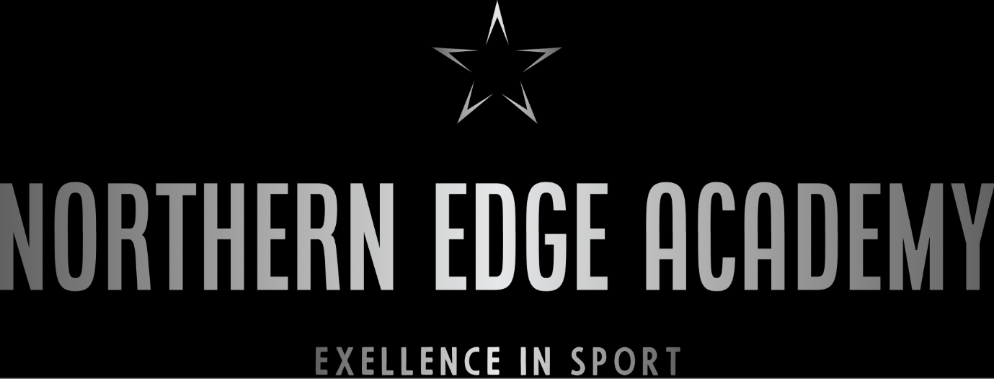

Data Protection Policy

Published | May 2025
Next Review | May 2026
Review Frequency | Annually

Introduction
Northern Edge is committed to protecting the privacy and personal data of its students, staff, and stakeholders. This data protection policy outlines the provisions approach to the collection, processing, storage, and sharing of personal data in accordance with the Data Protection Act 2018 and the General Data Protection Regulation (GDPR) 2016/679.

Data Collection and Processing
Northern Edge will collect and process personal data only for specific and lawful purposes, and will ensure that the data is accurate, relevant, and not excessive for the purpose for which it is processed. The provision will obtain consent from individuals for the collection and processing of their personal data, and will inform them of the purpose for which their data is collected. This will be part of the form that is signed during the pupil's induction process.

Data Storage and Security
Northern Edge will ensure that personal data is stored securely and protected against unauthorised or unlawful processing, accidental loss, destruction or damage. We will implement appropriate technical and organisational measures to ensure the confidentiality, integrity, and availability of personal data.

Data Sharing
Northern Edge will only share personal data with third parties when it is necessary for the purpose for which it was collected, and only when the necessary safeguards are in place to protect the privacy and security of the data.

Data Subject Rights
Northern Edge recognises the rights of individuals in relation to their personal data, including the right to access, correct, erase, and restrict the processing of their data. The provision will respond to requests from individuals in a timely and appropriate manner, and will ensure that all requests are handled in accordance with data protection laws.

Data Breach
In the event of a personal data breach, Northern Edge will take immediate steps to contain and assess the breach, and will notify the relevant authorities and affected individuals as required by data protection laws.

Conclusion
Northern Edge is committed to protecting the personal data of its students, staff, and stakeholders, and will ensure that all personal data is collected, processed, stored, and shared in accordance with data protection laws. The provision will regularly review and update this policy to ensure that it remains current and relevant.

